ECA5602- 5g/6g communication
Slot D
K. Naga Sai Nikhil Reddy
192412553

Experiment 2: MATLAB Simulation of Cellular Coverage, Cell Splitting and Handoff in a Multi-Cell Network
code:
clear; clc; close all;
% Baseline assumptions
serviceAreaKm2 = 5;
radiiKm = [1.0 0.5];
usersPerCell = 30;
hexArea = @(R) (3*sqrt(3)/2) .* R.^2;
cellAreaKm2 = hexArea(radiiKm);
cellCount = ceil(serviceAreaKm2 ./ cellAreaKm2);
estimatedUsers = cellCount .* usersPerCell;
capacityTable = table(radiiKm(:), cellAreaKm2(:), cellCount(:), ...
repmat(usersPerCell,numel(radiiKm),1), estimatedUsers(:), ...
'VariableNames', {'Radius_km','CellArea_km2','EstimatedCells', ...
'UsersPerCell','IllustrativeUsers'});
disp(capacityTable);
% Plot a 7-cell cluster: central cell plus six neighbors
R = radiiKm(1);
centers = [0 0; 1.5*R sqrt(3)*R/2; 1.5*R -sqrt(3)*R/2; ...
0 sqrt(3)*R; 0 -sqrt(3)*R; -1.5*R sqrt(3)*R/2; ...
-1.5*R -sqrt(3)*R/2];
theta = (0:6)*pi/3; % flat-top hexagon vertices
figure; hold on; axis equal; grid on;
for k = 1:size(centers,1)
plot(centers(k,1)+R*cos(theta), centers(k,2)+R*sin(theta), 'k-');
text(centers(k,1),centers(k,2),sprintf('Cell %d',k), ...
'HorizontalAlignment','center');
end
xlabel('x (km)'); ylabel('y (km)');
title('Idealized Seven-Cell Hexagonal Cluster');
hold off;
% Mobile moves across the boundary between centers at x=0 and x=1.5R
mobileX = linspace(-0.2*R,1.7*R,300);
mobileY = zeros(size(mobileX));
d1 = hypot(mobileX, mobileY);
d2 = hypot(mobileX-1.5*R, mobileY);
servingCell = ones(size(mobileX));
servingCell(d2 < d1) = 2;
handoffIndex = find(diff(servingCell) ~= 0,1,'first') + 1;
figure; hold on; grid on;
plot(mobileX,d1,'LineWidth',1.5);
plot(mobileX,d2,'LineWidth',1.5);
if ~isempty(handoffIndex)
xline(mobileX(handoffIndex),'--r','Handoff decision');
end
xlabel('Mobile x-position (km)'); ylabel('Distance to cell center (km)');
legend('Cell 1','Cell 2','Location','best');
title('Nearest-Center Handoff Approximation');
hold off;
figure; stairs(mobileX,servingCell,'LineWidth',1.5); grid on;
xlabel('Mobile x-position (km)'); ylabel('Serving-cell ID');
title('Serving Cell Along the Mobile Path');
if ~isempty(handoffIndex)
fprintf('Geometric handoff at x = %.3f km\n',mobileX(handoffIndex));
end

output:
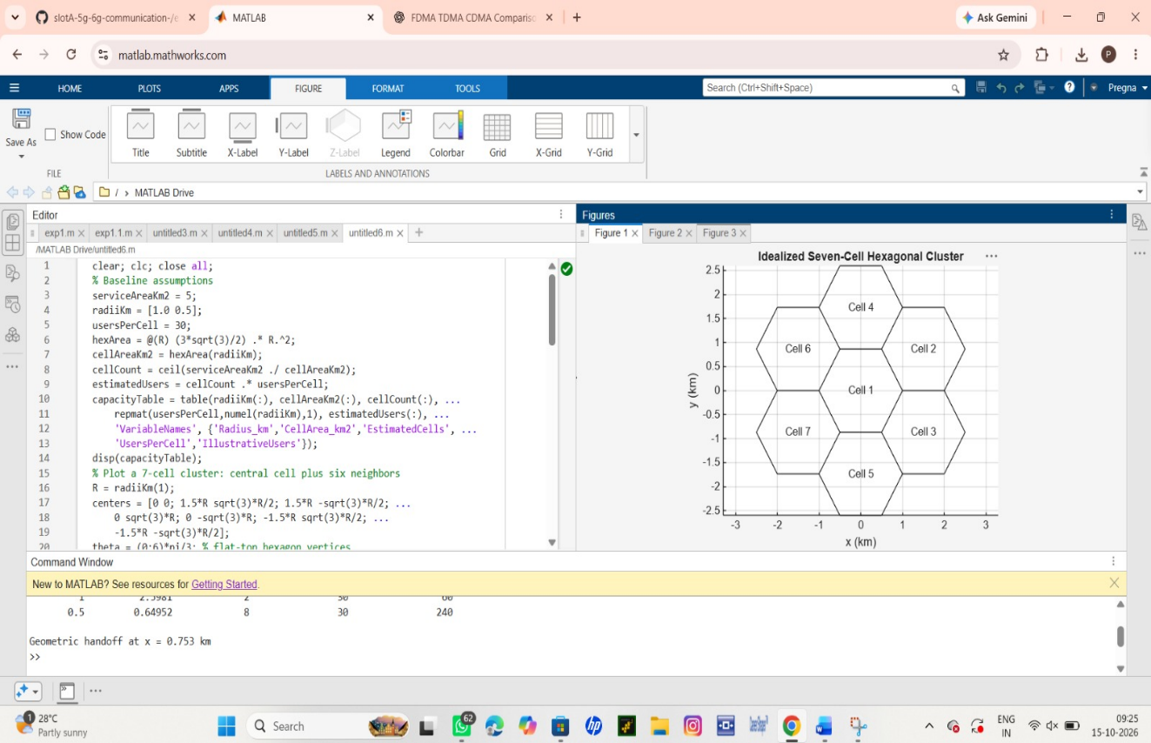
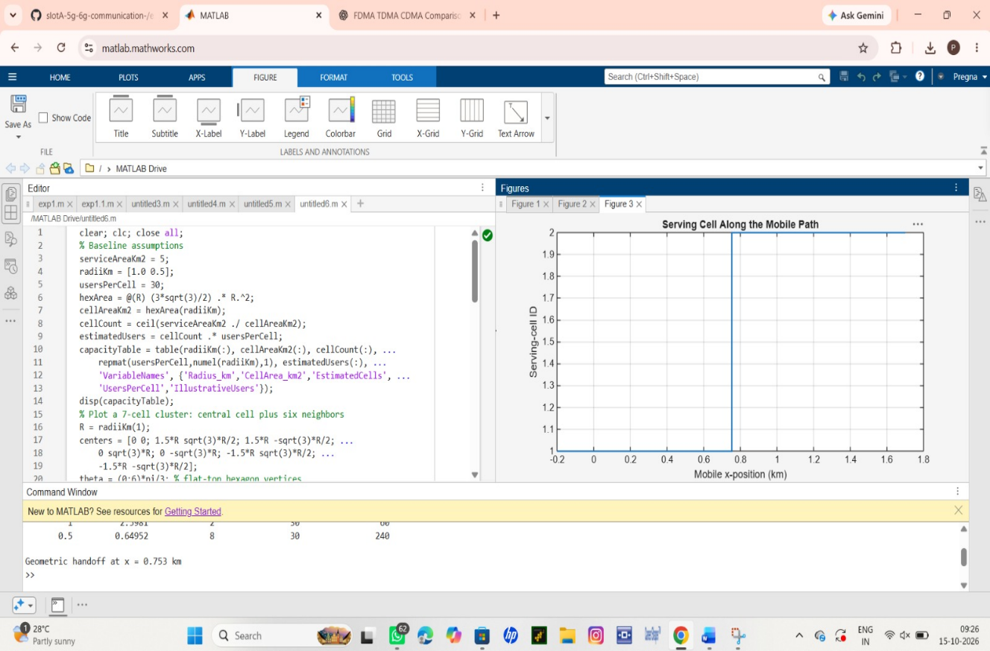
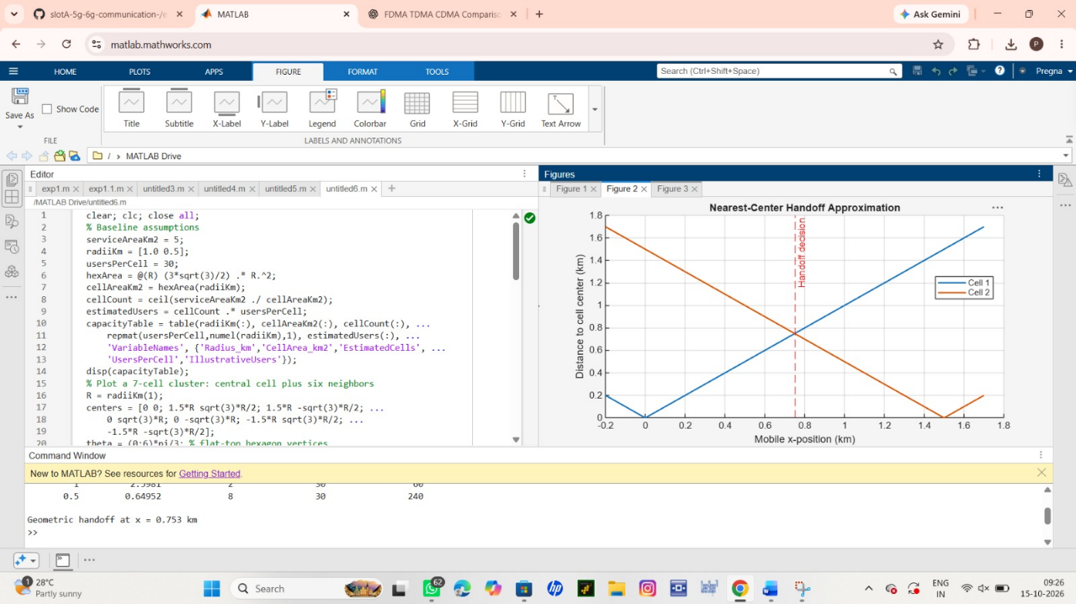
Conclusion
Summarize how cell radius changes the idealized cell count and assumed network capacity, and report the simulated handoff location. State that the model uses ideal hexagons, an area ratio count, fixed per-cell capacity and nearest-center handoff; it does not model RF propagation, overlap, fading, load or handoff timers.

